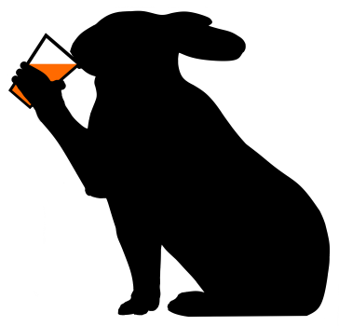
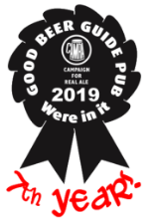
The March Hare
Freehouse

Dunton
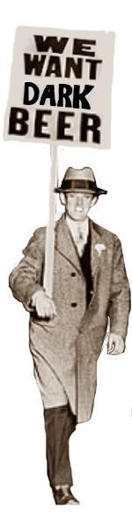
East Beds CAMRA Rural Pub of the Year 2015 and 2019
East Beds CAMRA Pub of the Year 2013

Winter Beer Fest the Seventh

“Because beer won’t drink itself...”

8th, 9th and 10th February 2019

Tasting Notes
Mainly Dark Beers….(And some others)
Beers served from , and

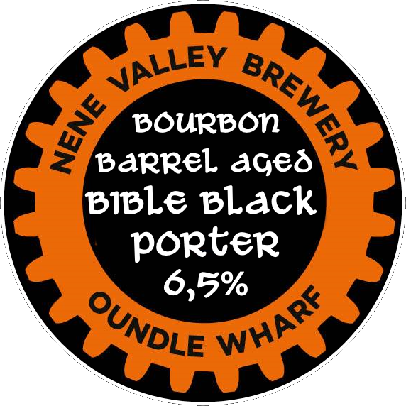Nene Valley Brewery, Oundle, Northamptonshire
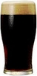
1. Bible Black 6.5% Barrel Aged Porter.
Champion Beer of Peterborough Beer Festival 2014 and brewed again last year
but this batch has been aged for three months in ex bourbon barrels! It’s now
ten months old at least!
We have been fortunate to obtain a small quantity of this rare beer and its cost is commensurate with its strength and the effort invested in its ingredients, brewing and maturation. It is priced at £5.40 pint, £2.70 half pint, £1.80 third pint. Well worth the experience. It is a rich dark beer with sweet cocoa and dark malt aromas.
The blend of various dark malts gives a lavish chocolate flavour and coffee like bouquet.

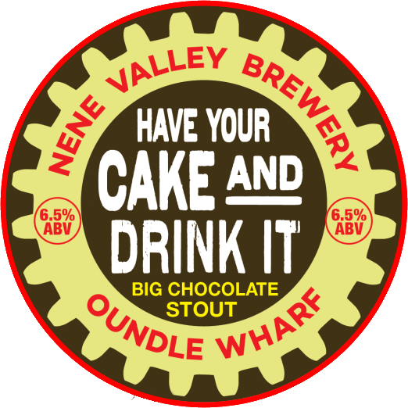2. Have Your Cake And Drink It 6.5%
A big chocolate stout. A smooth and rich stout with the addition of cocoa nibs
for a deep complex chocolate flavour, and oats for a full mouth feel. An initial
sweetness leads to a dark chocolate bitter finish. Chocolate cake in a glass!
Dispensed from craft keg.
This beer and is priced at £4.80 pint, £2.40 half pint, £1.60 third pint.
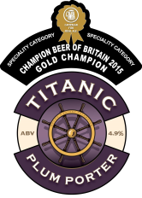
Titanic Brewery, Burslem, Staffordshire
3. Plum Porter 4.9%
A perennial favourite. This beer is dark, strong and well rounded. The richness of
such a rotund beer is brought to an even keel by the late addition of Goldings hops
and natural plum flavouring. Multi-award winning beer.

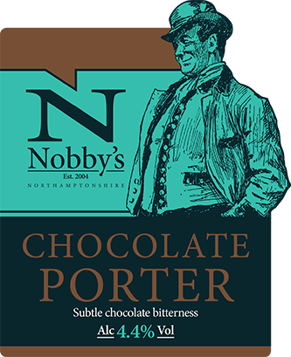Nobby’s Brewery, Thrapston, Northamptonshire
4. Chocolate Porter4.4 %
Very dark brown with cream head. There is a full, rich chocolate flavour.
Dark roasted malts show through with a fruity, plummy edge.
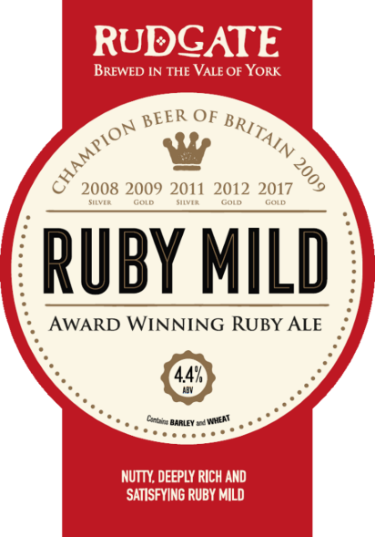 Rudgate Brewery, Tockwith, Yorkshire
5. Ruby Mild 4.4%
The brewery is situated at the heart of Yorkshire in the Vale of York.
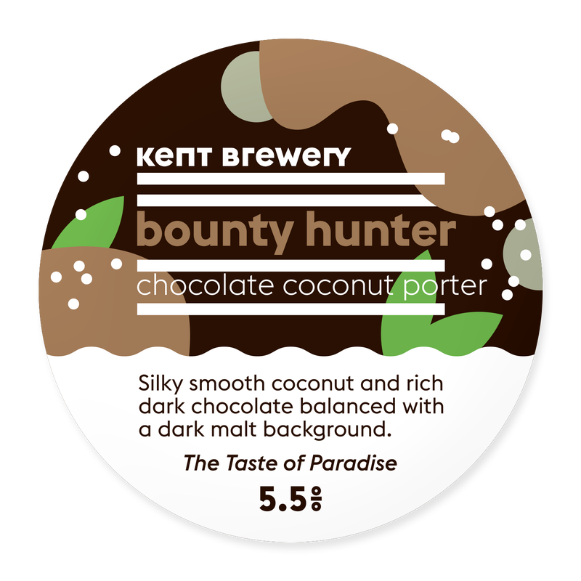A rich and satisfying multi-award winning English dark mild ale.
Kent Brewery, Birling Place Farm, Birling, Kent
6. Bounty Hunter 5.5%
Silky smooth coconut and rich dark chocolate balanced with a
dark malt background
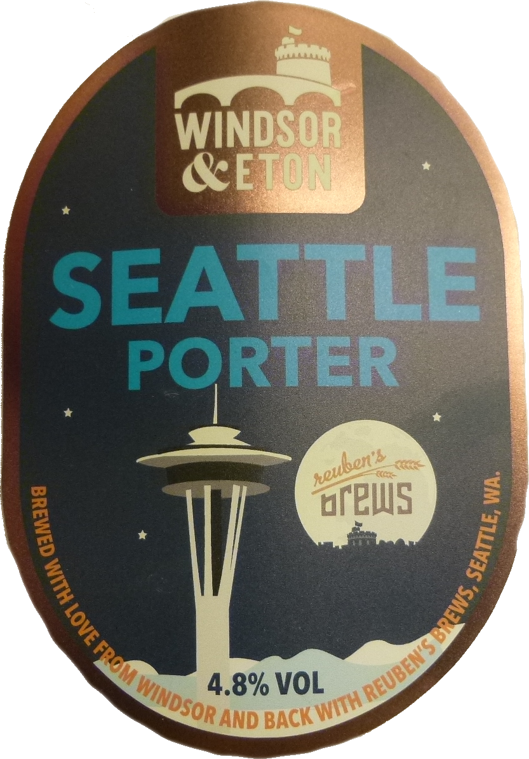Windsor and Eaton Brewery, Windsor, Berks
7. Seattle Porter 4.8%
Classic dark strong porter full of toasted roast malt flavours with dark fruit, chocolate,
and coffee notes, with dark fruit aromas. Collaboration brew with US Rueben's Brews.
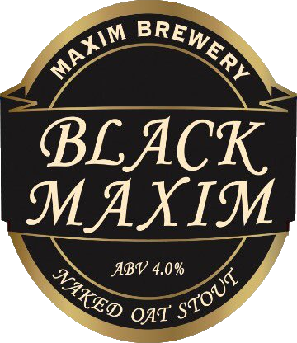Maxim Brewery, Houghton-le-Spring, Tyne and Wear
8. Black Maxim Naked Oat Stout 4%
Naked Oat Stout! An easy drinking, dark, flavoursome stout made with roast
barley, chocolate malt and Willamette hops.
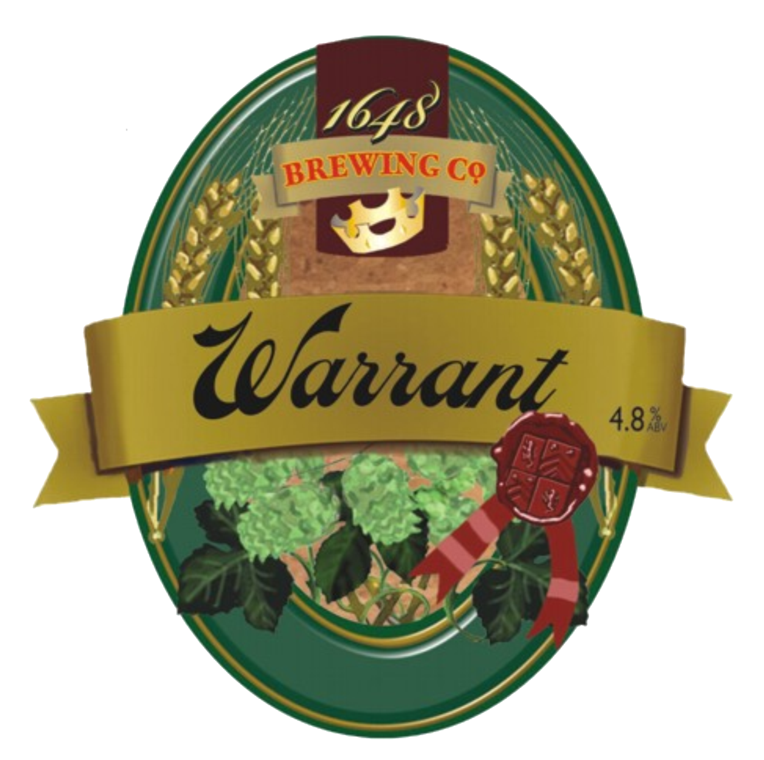1648 Brewing Company, East Hoathly, East Sussex,
9. Warrant Porter 4.8 %
A full bodied, deeply flavoured, dark winter ale. An intense winter porter
packed with complex coffee, chocolate and nutty flavours.
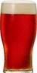
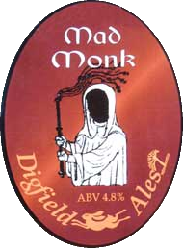Digfield Ales, Barnwell, Northamptonshire
10. Mad Monk 4.8%
Deliciously full-bodied best bitter with masses of flavour. Slightly darker,
this strong ale has hints of malt and chocolate in the finish. Cask conditioned
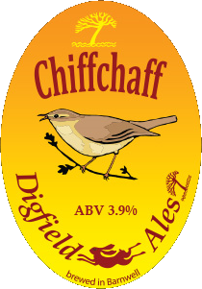for several months.
11. Chiffchaff 3.9%
Award winning easy drinking, clean, crisp and fantastically refreshing
amber-gold pale ale with a distinct hoppy aroma
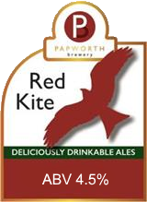Papworth Brewery, Earith, Cambridgeshire
12. Red Kite 4.5%
Well balanced ruby ale with four different malts and a long, strong hop finish,
Bursting with tropical fruit flavours from the gratuitous overuse of hops.
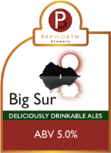
13. Big Sur 5%
Big Sur is the coastal region of California, south of Monterey, famed for its
beautiful unspoiled wilderness and huge mountains. This West Coast pale ale
is brewed in the Californian style, with a deceiving strength and huge
American hop flavours.
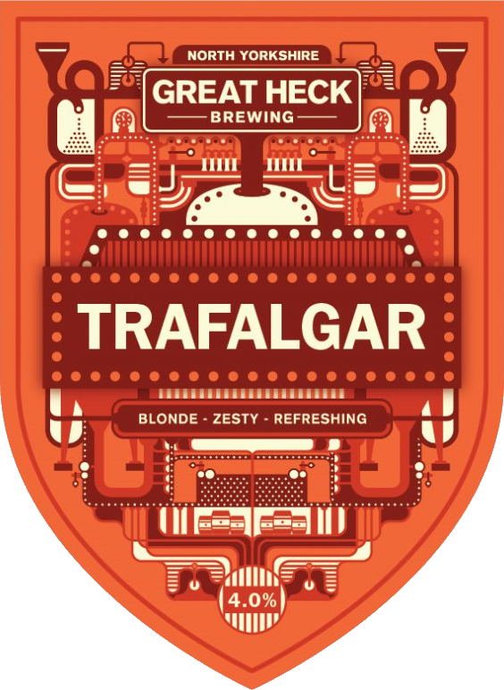Great Heck Brewing Company, Great Heck, North Yorkshire
14. Trafalgar 4%
Extra pale ale with moderate bitterness but packed with tons of exotic, fruity
flavours and aromas. Featuring heaps of Columbus hops late in the boil and
Nelson Sauvin during fermentation, the beer is named in honour of Admiral Lord Nelson.

