THE MARCH Hare

Freehouse, Dunton

Home of quality beer

Is proud to be part of
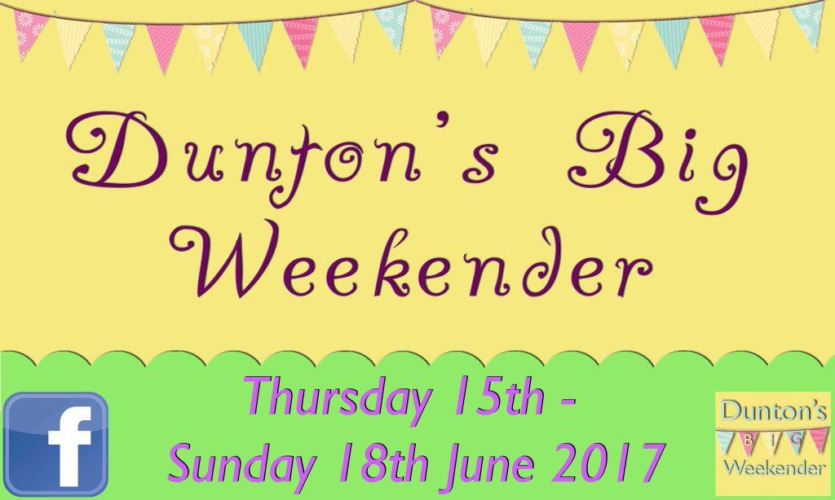

A great weekend for all the family

Thursday 15th June learn how to play Crib or Backgammon From
8.00 pm, players from The March Hare will be here to show you how

Thursday 15th June to Sunday 18.6.17

Mini real ale festival
8 real ales over the weekend
3 summery light and hoppy beers on the stillage in the bar

Saturday 17.6.17 Tim Edey
Will be playing in St Mary Magdalene Church from 8.00pm
Where the acoustics are wonderful
Doors open at 7.30pm
We shall be there with the March Hare outside bar

Sunday 18.6.17 Car Treasure Hunt
Commences from the March Hare 11.00am

Sunday 18.6.17 Father’s Day
Does your dad enjoy real ale? The March Hare could solve one of your Father’s Day problems! With John’s excellent Range of well-kept real
ales, a comfortable interior or the beer Garden, the March Hare is the ideal place to take dad for Father’s Day. If he has never pulled a pint of beer before but has always wanted to, he can at The March Hare!!
Today!! Just ask at the bar!
Or if you prefer you can take your dad to the Village Fete where the
Hare Beer Bunch will be serving real ale from their Bangers,
Burgers and Beer stall from 1.00 pm – 4.30 pm

Sunday 18.6.17 Father’s Day Quiz night 7.30pm
Teams of up to 6 may play. in aid of raising money for next year’s
Dunton’s Big Weekender. Minimum donation of £2.50 per player

